Here is the workaround for the Set up and Configure a Cloud Environment in Google Cloud Lab.   

Task 1:

Use the GUI

or

|  |
| --- |
| gcloud compute networks create griffin-dev-vpc --subnet-mode custom  gcloud compute networks subnets create griffin-dev-wp --network=griffin-dev-vpc --region us-east1 --range=[192.168.16.0/20](http://192.168.16.0/20)  gcloud compute networks subnets create griffin-dev-mgmt --network=griffin-dev-vpc --region us-east1 --range=[192.168.32.0/20](http://192.168.32.0/20) |

Task 2:

Use Cloud Shell

|  |
| --- |
| gsutil cp -r gs://cloud-training/gsp321/dm .  cd dm  sed -i s/SET_REGION/us-east1/g prod-network.yaml  gcloud deployment-manager deployments create prod-network \      --config=prod-network.yaml  cd .. |

Task 3:

Create in GUI (or use gcloud)

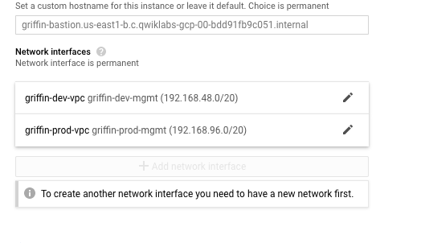

|  |
| --- |
| gcloud compute instances create bastion --network-interface=network=griffin-dev-vpc,subnet=griffin-dev-mgmt  --network-interface=network=griffin-prod-vpc,subnet=griffin-prod-mgmt --tags=ssh --zone=us-east1-b  gcloud compute firewall-rules create fw-ssh-dev --source-ranges=[0.0.0.0/0](http://0.0.0.0/0) --target-tags ssh --allow=tcp:22 --network=griffin-dev-vpc  gcloud compute firewall-rules create fw-ssh-prod --source-ranges=[0.0.0.0/0](http://0.0.0.0/0) --target-tags ssh --allow=tcp:22 --network=griffin-prod-vpc |

Task 4:

|  |
| --- |
| gcloud sql instances create griffin-dev-db --root-password password --region=us-east1  gcloud sql connect griffin-dev-db  # Cut and paste the SQL  CREATE DATABASE wordpress;  GRANT ALL PRIVILEGES ON wordpress.* TO "wp_user"@"%" IDENTIFIED BY "stormwind_rules";  FLUSH PRIVILEGES; |

Task 5:

|  |
| --- |
| gcloud container clusters create griffin-dev \    --network griffin-dev-vpc \    --subnetwork griffin-dev-wp \    --machine-type n1-standard-4 \    --num-nodes 2  \    --zone us-east1-b |
|  |

Task 6:

|  |
| --- |
| gcloud container clusters get-credentials griffin-dev --zone us-east1-b  cd ~/  gsutil cp -r gs://cloud-training/gsp321/wp-k8s .  cd wp-k8s  sed -i s/username_goes_here/wp_user/g wp-env.yaml  sed -i s/password_goes_here/stormwind_rules/g wp-env.yaml  kubectl create -f wp-env.yaml  gcloud iam service-accounts keys create key.json --iam-account=cloud-sql-proxy@$[GOOGLE_CLOUD_PROJECT.iam.gserviceaccount.com](http://google_cloud_project.iam.gserviceaccount.com/)  kubectl create secret generic cloudsql-instance-credentials --from-file key.json |

Task 7:

|  |
| --- |
| I=$(gcloud sql instances describe griffin-dev-db --format="value(connectionName)")  sed -i s/YOUR_SQL_INSTANCE/$I/g wp-deployment.yaml  kubectl create -f wp-deployment.yaml  kubectl create -f wp-service.yaml |

Task 8:

|  |
| --- |
| ## Create uptime check in the Monitoring GUI (In the hostname use IP address of Load Balancer) |
|  |

Task 9:

|  |
| --- |
| gcloud projects add-iam-policy-binding $GOOGLE_CLOUD_PROJECT --member=user:<2nd user email> --role=roles/editor |